

Product form (English)

HS Code (harmonized system code)
7214.20

Name of the product
Reinforcing Deformed Steel Bars

Product Description
Quality: ASTM A615 Grade 60
Invoicing: Actual Weight Basis
Sizes: 8mm-20mm
Length: 6 meters (+,- 50mm)

Composition
Steel

Illustrative photo of the product

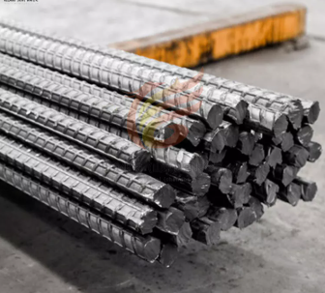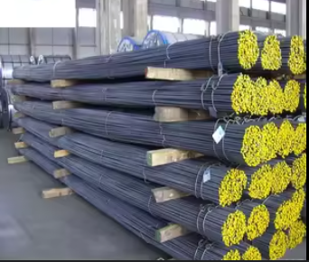

VOLUME IN the first purchase
1 Container HC

